Please note the following information from the BC Centre for Disease Control Website:
- What to do if you test positive for COVID-19 and
- How travel quarantine periods impact children returning to school in-person
is provided by public health and compiled by the Burnaby School District for your easy reference.
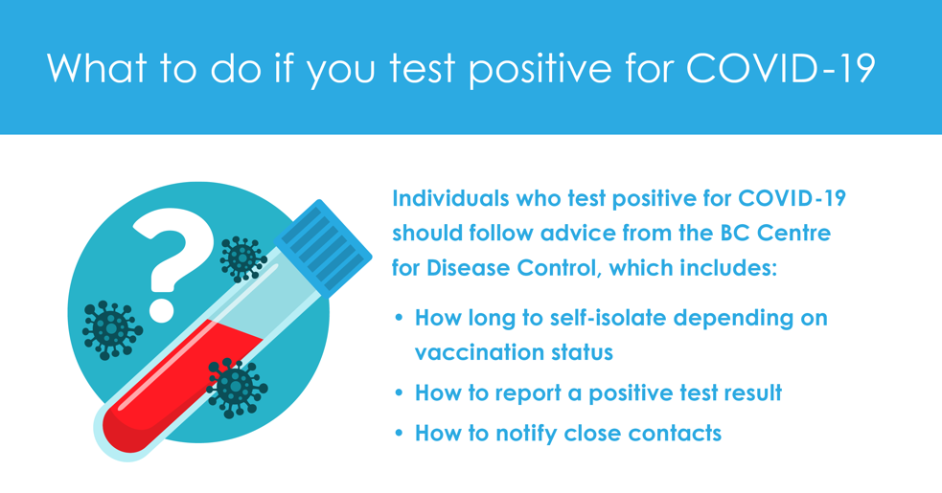
More information can be found here:
http://www.bccdc.ca/health-info/diseases-conditions/covid-19/if-you-have-covid-19
As public health is not contacting every person who tests positive, they will no longer be issuing school exposure letters for individual cases for principals to distribute.
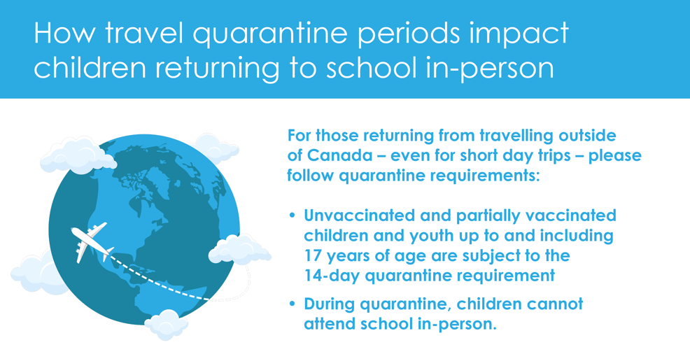
Families planning to travel or who have returned from international travel are encouraged to check the Government of Canada’s website for the most up-to-date quarantine and testing requirements.
More information can be found here: www.travel.gc.ca/travel-covid

Posted January 13, 2022

